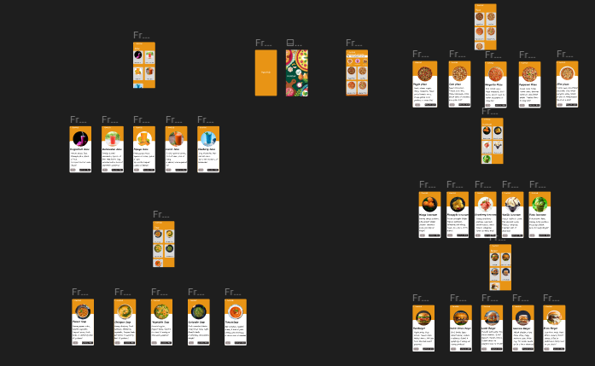

**Task 3: Restaurant Menu**